

Gold and Glory

**Fantastic Four © 2014**

Created in Experimental Game Design, Fall 2014

at Rensselaer Polytechnic Institute

Developers

**Alexander Foo** (fooa@rpi.edu) – Character and Enemy Art

**Dustin Tsui** (tsuid@rpi.edu) – Enemy AI

**Peregrin Garet** (garetp@rpi.edu) – Character and UI Programming

**Reginald Franklin** (frankr4@rpi.edu) – HUD and Environment Art

*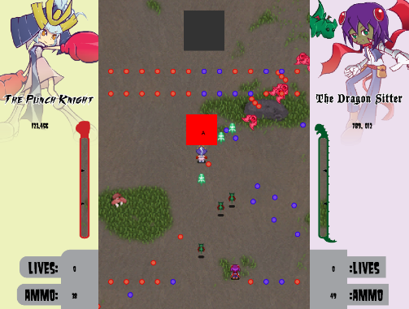Gold and Glory* is a bullet hell following in the footsteps of classics in the genre such as Touhou and Ikaruga, but with a cooperative twist. The two players control members of a ragtag mercenary squad seeking out fame and fortune wherever they please. At any given time, one player is the Attacker and the other the Defender, while the enemies shoot two different types of bullets. The Attacker returns fire while the Defender utilizes his shields, whose affinity can be swapped between one type of bullet or the other, to provide the Attacker a path of least resistance. At the same time, for every bullet the Defender’s shield absorbs, he gains ammo, which he can use when the players decide to swap roles, creating a powerful dynamic between the two players which they can use in combination with their unique mechanics and specials to destroy everything in their path. *Gold and Glory* is built in Unity with the art done in Photoshop.